**Stage 2- I live, I die. I LIVE AGAIN!**

**RULES:** USPSA Competition Rules, Latest Edition **COURSE DESIGNER:** Rocky Perillo

|  |  |
| --- | --- |
| **START POSITION: See written stage briefing.** | |
| **STAGE PROCEDURE**  See written stage briefing. | **SCORING**  **SCORING:** Comstock 23 rounds.  **TARGETS:** 11 cardboard targets, 1 steel target  **SCORED HITS:** 2 Best hits per carboard will be scored. Steel must fall to score.  **START-STOP:**  Audible - Last shot  **PENALTIES:** Per USPSA Competition Rules |

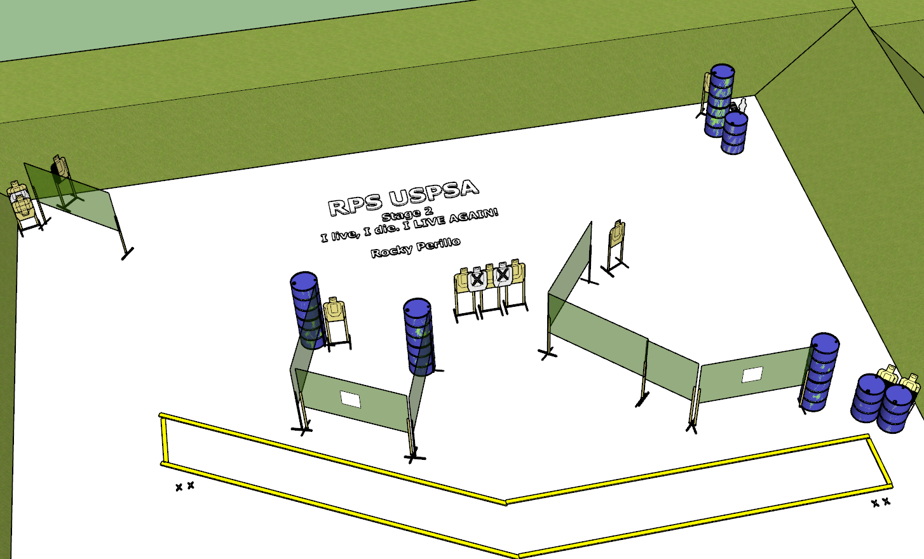

**Written Stage Briefing:**

**Stage 2 – I live, I die. I LIVE AGAIN! –** is a 23-round, 115 point, Comstock Long Course. There are 11 cardboard targets and 1 steel target. The best 2 hits per cardboard target will be scored. The steel must fall to score.

**Start position** Both feet on either set of Shooting Sports Innovation Xs

**Handgun**: Loaded and holstered with wrists below belt.

**PCC**: Loaded, stock on belt.

On the audible start signal, engage targets from within the shooting area.

**USPSA / NROI Range Commands:**

* Make Ready
* Are you ready?
* Standby
* If finished, unload and show clear.
* If clear, hammer down and holster
* Range is clear

**Setup Notes:**

6 Single Wall Stands

5 Double Wall Stands

5 Full Walls

2 Ported Walls

1 Half Wall

8 Target stands

2 45 degree target stands

20 target sticks

12+ barrels

2 Starting Xs